 | 3 - Interface
Table of content
Tooltips 2
Interface 2
User Interface Principles 2
Splash Screen 3
Header 3
Scroll Header 4
Panels 4
Pinning panels 4
Open just one Panel at a time 5
Tabs 5
Menus, Buttons and Controls 5
Menu 5
Menu Search 5
Button 5
Toggles 6
Edit Box 6
Snapping 6
Drop down box 6
Color Picker 7
Widgets 7
Cursors 7
Value Editing 7
Multi Value Editing 7
Expressions 7
Expressions as Drivers 8
Units 8
Unit Names 8
Menu shortcuts 9
Tool Shelf 9
Opening and closing by menu and hotkey 9
Resize 9
Open Tool Shelf by Plus Button 9
Sidebar 10
Opening and closing by menu and hotkey 10
Resize 10
Open Sidebar by Plus Button 10
Input Devices 10
Non English Keyboard 10

Tooltips
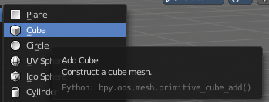
When you hover with the mouse over an UI element, like a button, then you can see a tooltip.
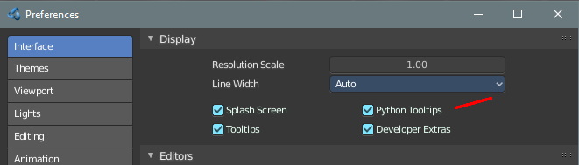
A tooltip can contain the tool name, a short description of the tool, the hotkey, and a Python tooltip.

The Python tool tip shows you the name of the operator. It is of interest for programming needs. It can be turned off in the User Preferences.

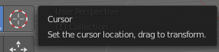
The tool tips in the Tool Shelf acts a bit different than the tool tips in the rest of the UI. It will not show you the Python tool tips, since it is a gigantic hack on top of the existing UI.

Interface
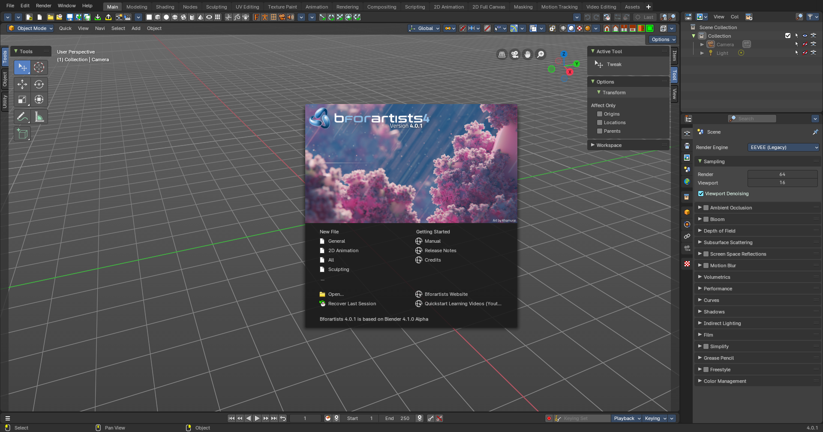

User Interface Principles
The UI is made of several different workspaces. Each workspace is made of several editors for the different purposes. And this editors are made of several sub elements. Like a Header or a tool shelf, or a sidebar. UI elements are organized in tabs, menus and panels.
The idea is to have a non overlapping and blocking UI with a non modal tool set. Which is just partially to achieve. See header below. And by the fact that you work in modes ...
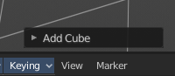
As a consequence of the non overlapping UI concept, the interface avoids to work with popup panels where possible. You can adjust the tool after you use it, in the so called last operation panel. It can be found in the 3D view for example, down left.

Splash Screen

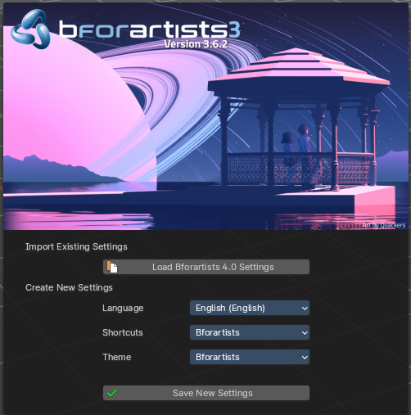
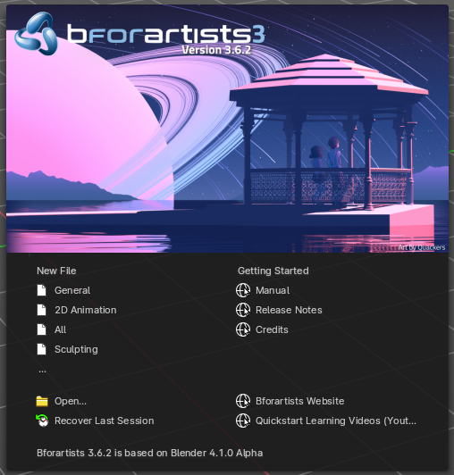

The splash screen shows at startup. The splash screen will vanish when you click with the mouse. You can also turn its showing at startup completely off in the User Preferences.

At the very first start you can do a quick setup, and choose with what language and key map and what theme you want to work. Clicking at the Next button will then make this change permanent.

It is recommend to click at the Next button, since it creates some needed directories.

When you don't have any recent files, then the splash screen shows a Getting Started section with some links to useful resources.

And when you have recent files, then the splash screen lists them instead of the Getting Started section.

In the splash screen you can also read at what Blender version the current Bforartists version is based at.

Header

Every editor has a header area. It usually contains the menu. And some tools or settings.

Scroll Header
A header can be scrolled! This is especially useful in the layouts where the header is this crowded with tools that it doesn't fit to display all content into the layout anymore. This is for example the case in the UV layout.
To scroll the header, click with the middle mouse button at it, and drag.

Panels

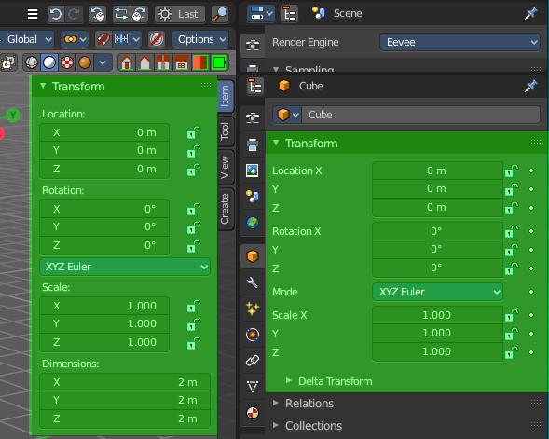
A Panel is a container that contains tools and settings. They are used in quite a few locations. In the Properties editor for example. Or in the sidebars.
Panels can be rearranged in order. Simply drag them over each other to achieve the order that you need.
Panels can be expanded and collapsed by clicking at the title bar.
When you hold down ctrl and click at the title bar then this panel will open, and all other panels will close.

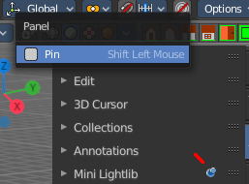
Pinning panels

Normally the tabs just displays the panels of the current tab. But you can pin panels so that they display always. This counts also for content from other tabs. Here i have pinned the panel from the Mini Lightlib in the Create tab. And it shows in the View tab now.
Right click at the tab that you want to pin. A menu pops up. Check the Pin checkbox. The tab will now show a pin, and will display permanently.
To unpin the panel simply click at the Pin icon.

Open just one Panel at a time
This can be done by clicking at the header of a panel and holding down ctrl.

Tabs
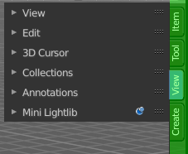
The Sidebars can have Tabs to switch between different content. Also the Properties editor has them. The tabs helps to organize the available tools into categories. In the 3D view it's also a common place where addons adds themselves.

Menus, Buttons and Controls

The UI contains various control elements. Buttons, Menus, toggles, etc.

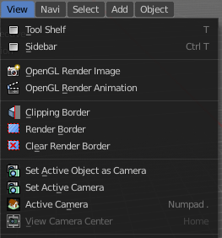
Menu

In the header you may find text menus. A text menu contains usually buttons. But it can also contain toggles. Or other menus.

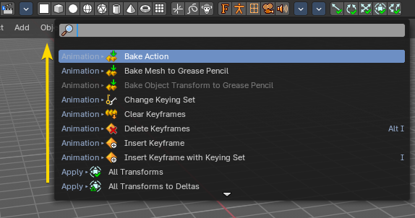
Menu Search
You can search any header menu while it is open with the search menu operator by pressing SPACE. This will allow filtering the menu contents without navigating into the sub-menus.

Button
A button is a UI element that allows you to perform an operation at click. There are various button types in the UI. Text Buttons in the text menus, text buttons in the panels, and icon buttons in the header and in the tool shelf.

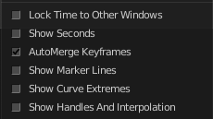
Toggles
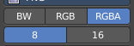
Toggles can be radio buttons. But also icon or text buttons. Where they are the same is that they have states. On and off for example. They can also have more states than just two.

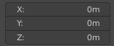
Edit Box
Some UI elements are editable. Edit boxes are used for things like position, angle, name, etc. . Click into the editable area to enter the edit mode. Do the changes, like typing in a new value, then press Enter to confirm the change.
Value edit boxes have some extra functionality. They work as sliders too. Hover with the mouse over the edit box. The mouse cursor will turn into two arrows.

Snapping
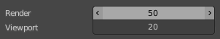
Sliders can snap incrementally. Hover with the mouse over the slider, start to slide, and holding down Ctrl will snap the sliders in incremental steps.
When it's a default value between 0 and 1 then it usually snaps in 0.1 steps. When it's a default value over 1 then it usually snaps in steps of 10.

Drop down box
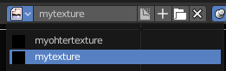
A drop down box is another kind of a menu. Usually you choose something here. Like a special setting. Or when you add a modifier. A list drop down box can show you the loaded textures for example. and allow you to choose another one.
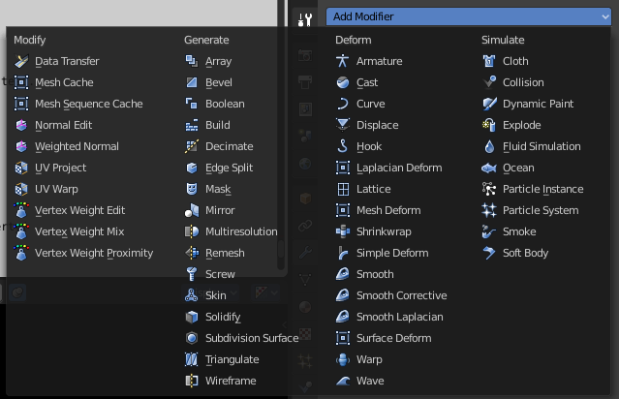

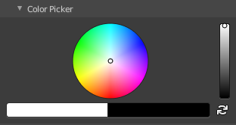
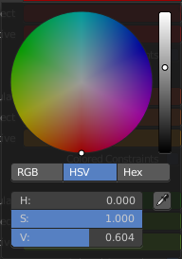
Color Picker
You may stumble across color pickers in the UI. When you do a painting job for example. This allows you to adjust color for the specific task. Like adjusting the brush color.

Widgets
There are various widget types in Bforartists to find. Most of them in the 3D View. Widgets allows you to manipulate the transformation along one or more axis.

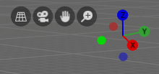
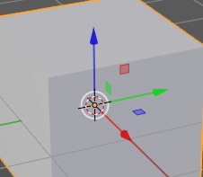
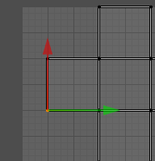

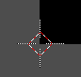
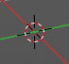
Cursors
A cursor is a center point, and allows manipulation in different ways. Objects gets created at the 3D cursor in the 3D view. You can set the cursor at different locations. You can snap it to elements, and you can snap elements to it.

Value Editing

You will find lots of value edit boxes in the Bforartists interface. To set the render size for example. Or to set the position of an object.

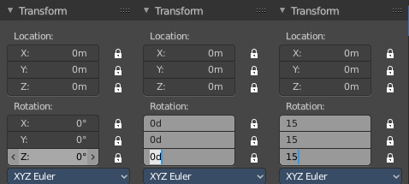
Multi Value Editing
Sometimes you want to edit multiple values at once. The object scale for example. This can be done by clicking into the first edit box, and then drag with the mouse across the other edit boxes. They will become active now. And when you edit one value, then the other values will change too.

Expressions
You can also enter expressions in value edit boxes. And the result will be calculated. For example, 3*2 instead of 6. or 5/10+3. Even constants like pi (3.142) or functions like sqrt(2) (square root of 2) may be used.

Expressions as Drivers
You may want your expression to be re-evaluated after its entered. Blender supports this using Drivers (a feature of the animation system).
Expression beginning with #, have a special use. Instead of evaluating the value and discarding the expression, a driver is added to the property with the expression entered.
The expression #frame is a quick way to access map a value to the current frame, but more complex expressions are also supported #fmod(frame, 24) / 24 for example.
This is simply a convenient shortcut to add drivers which can also be added via the RMB menu.

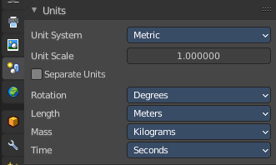
Units
You can mix units with numbers. This means when you work in meters, then you can type in cm for centimeters. And the correct value will be used then.
You can even mix units in the same expression. For example 1m, 3mm. Or do complex mathematical calculations like 2.2mm + 5' / 3" - 2yards . Commas are optional.
Units can be adjusted in the Properties Editor in the Scene tab in the Units panel.
Such units needs to be set in the scene settings. Metric or Imperial.

Unit Names
Unit names have can be used with both long and short forms. Both is recognized.
Here is a list of recognized unit names you can use. Plurals of the names are recognized too, so meter and meters can both be used.

Imperial Units
Full Name | Short Name(s) | Scale of a Meter
thou | mil | 0.0000254
inch | ", in | 0.0254
foot, feet | ', ft | 0.3048
yard | yd | 0.9144
chain | ch | 20.1168
furlong | fur | 201.168
mile | mi, m | 1609.344

Metric Units
Full Name | Short Name(s) | Scale of a Meter
micrometer | um | 0.000001
millimeter | mm | 0.001
centimeter | cm | 0.01
decimeter | dm | 0.1
meter | m | 1.0
dekameter | dam | 10.0
hectometer | hm | 100.0
kilometer | km | 1000.0

Menu shortcuts

- Arrow keys can be used to navigate into a menu
- Each menu item has an underlined character which can be pressed to activate it.
- Number keys or numpad can be used to access menu items. (Where 1 is the first menu item, 2 the second... etc. For larger menus Alt-1 the 11th... up to Alt-0 the 20th)
- Press Return to activate the selected menu item.
- Press Esc to cancel the menu.

Tool Shelf
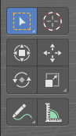
Some editors have a Tool Shelf at the left side. This tool shelf contains the tools. It can be resized by dragging. It can be closed and opened.

Opening and closing by menu and hotkey
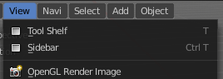
The view menu provides you with menus to close and to open the Tool shelf.
It also shows the hotkey.

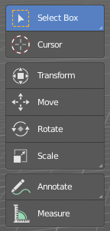
Resize
You can grab the border and drag the Tool Shelf and the Properties Sidebar to the left or to the right to expand or to close it.
The tool shelf shows a special behavior when you drag it bigger. Then the icon buttons becomes text buttons.

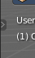
Open Tool Shelf by Plus Button
When a sidebar is closed then you will see a little plus button. When you click at this button then the sidebar will reappear.

Sidebar
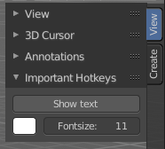
Some editors have a Sidebar at the right side. It can be resized by dragging. It can be closed and opened.

Opening and closing by menu and hotkey
The view menu provides you with menus to close and to open the Tool shelf.
It also shows the hotkey.

Resize
You can grab the border and drag the Sidebar to the left or to the right to expand or to close it.

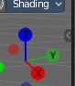
Open Sidebar by Plus Button
When a sidebar is closed then you will see a little plus button. When you click at this button then the sidebar will reappear.

Input Devices

Bforartists supports various types of input devices:
- Keyboard (recommended: keyboard with numeric keypad, English layout works best)
- Mouse (recommended: 3 button mouse with scroll wheel)
- NDOF Devices (also known as 3D Mouse)
- Graphic Tablets

Non English Keyboard
If you use a keyboard with a non-English keyboard layout, you may stumble across bugs and quirks and odd behaviors. Blender was developed for and with the UK or US layout. Some quirks for other keyboard layouts slipped through. And quite a few of those old bugs are still unfixed in Bforartists too.

